UX Design Sales Subsytem by Himank Kadian

# ERD for UX process

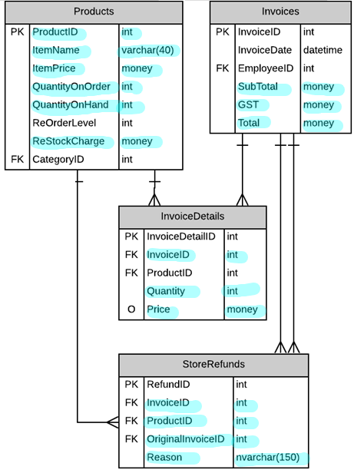

# Possible UX Interface

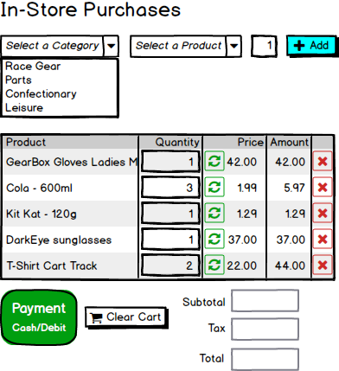

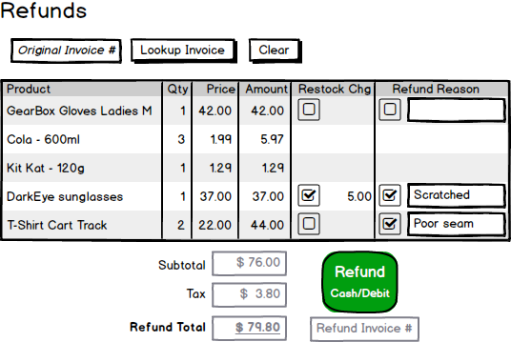

# ViewModels:

Place your ViewModel(s) here.

public class ProductViewModel

{

public int ProductID { get; set; }

public string ItemName { get; set; }

public int QuantityOnOrder { get; set; }

public int QuantityOnHand{ get; set; }

}

public class StorePurchaseViewModel

{

public int InvoiceID { get; set; }

public string ItemName { get; set; }

public decimal Price { get; set; }

public int Quantity { get; set; }

public int Amount { get; set; }

public int SubTotal { get; set; }

public int GST { get; set; }

public int Total { get; set; }

public decimal RestockCharge { get; set; }

}

public class StoreRefundViewModel

{

public int OriginalInvoiceID { get; set; }

public int InvoiceID { get; set; }

public int ProductID { get; set; }

public string Reason { get; set; }

}

# Event and Wiring Summations

Place your Event and Wiring Summations here.

**In-Store Purchases**

public List<CategoryViewModel> ViewCategories()  
{ /* Query from Categories */}

public List<ProductViewModel> ProductsByCategory(int CategoryID)  
{ /* Query from Products*/}

public List<StorePurchaseViewModel> AddProductToOrder(int ProductID)  
{ /* Command modifying List<StorePurchaseViewModel> */}

public void RefreshOrder(int ProductID)  
{ /* Command modifying List<StorePurchaseViewModel> */}

public void DeleteItem(int ProductID)  
{ /* Command modifying List<StorePurchaseViewModel> */}

public void OrderPayment(StorePurchaseViewModel currentOrder)  
{ /* Command modifying Products, Invoices and InvoiceDetails*/}

public void ClearCart()  
{ /* Command to empty all fields */ }

**Refunds/Returns**

public void ViewInvoice(int InvoiceID)  
{ /* Query from Products, Invoices, InvoiceDetails and StorePurchaseViewModel */}

public void Refund(int InvoiceID, int ProductID)  
{ /* Command modifying Products, Invoices, InvoiceDetails and StoreRefunds*/}

public void Clear()  
{ /* Command to empty all fields */ }